Cycle 2

Design a registration activity and store registration details in local memory of phone using Intents and SharedPreferences

code

xml1

<?xml version="1.0" encoding="utf-8"?>
<android.support.constraint.ConstraintLayout xmlns:android="http://schemas.android.com/apk/res/android"
xmlns:app="http://schemas.android.com/apk/res-auto"
xmlns:tools="http://schemas.android.com/tools"
android:layout_width="match_parent"
android:layout_height="match_parent"
tools:context=".MainActivity">
<EditText
android:id="@+id/add"
android:layout_width="wrap_content"
android:layout_height="wrap_content"
android:ems="10"
android:hint="Address"
android:inputType="textPostalAddress"
app:layout_constraintBottom_toBottomOf="parent"
app:layout_constraintEnd_toEndOf="parent"
app:layout_constraintHorizontal_bias="1.0"
app:layout_constraintStart_toStartOf="parent"
app:layout_constraintTop_toTopOf="parent"
app:layout_constraintVertical_bias="0.412" />
<EditText
android:id="@+id/email"
android:layout_width="wrap_content"
android:layout_height="wrap_content"
android:ems="10"
android:hint="Email"
android:inputType="textWebEmailAddress"
app:layout_constraintBottom_toBottomOf="parent"
app:layout_constraintEnd_toEndOf="parent"
app:layout_constraintHorizontal_bias="1.0"
app:layout_constraintStart_toStartOf="parent"
app:layout_constraintTop_toTopOf="parent"
app:layout_constraintVertical_bias="0.661" />
<EditText
android:id="@+id/phone"
android:layout_width="wrap_content"
android:layout_height="wrap_content"
android:ems="10"
android:hint="Phone"
android:inputType="phone"
app:layout_constraintBottom_toBottomOf="parent"
app:layout_constraintEnd_toEndOf="parent"
app:layout_constraintHorizontal_bias="1.0"
app:layout_constraintStart_toStartOf="parent"
app:layout_constraintTop_toTopOf="parent"
app:layout_constraintVertical_bias="0.529" />
<TextView
android:id="@+id/t1"
android:layout_width="132dp"
android:layout_height="30dp"
android:text="Name"
android:textAlignment="center"
android:textStyle="bold"
app:layout_constraintBottom_toBottomOf="parent"
app:layout_constraintEnd_toEndOf="parent"
app:layout_constraintHorizontal_bias="0.093"
app:layout_constraintStart_toStartOf="parent"
app:layout_constraintTop_toTopOf="parent"
app:layout_constraintVertical_bias="0.313" />
<TextView
android:id="@+id/t4"
android:layout_width="132dp"
android:layout_height="30dp"
android:text="Email"
android:textAlignment="center"
android:textStyle="bold"
app:layout_constraintBottom_toBottomOf="parent"
app:layout_constraintEnd_toEndOf="parent"
app:layout_constraintHorizontal_bias="0.093"
app:layout_constraintStart_toStartOf="parent"
app:layout_constraintTop_toTopOf="parent"
app:layout_constraintVertical_bias="0.659" />
<TextView
android:id="@+id/t2"
android:layout_width="132dp"
android:layout_height="30dp"
android:text="Address"
android:textAlignment="center"
android:textStyle="bold"
app:layout_constraintBottom_toBottomOf="parent"
app:layout_constraintEnd_toEndOf="parent"
app:layout_constraintHorizontal_bias="0.093"
app:layout_constraintStart_toStartOf="parent"
app:layout_constraintTop_toTopOf="parent"
app:layout_constraintVertical_bias="0.413" />
<TextView
android:layout_width="230dp"
android:layout_height="37dp"
android:text="REGISTER"
android:textAlignment="center"
android:textSize="24sp"
app:layout_constraintBottom_toBottomOf="parent"
app:layout_constraintHorizontal_bias="0.497"
app:layout_constraintLeft_toLeftOf="parent"
app:layout_constraintRight_toRightOf="parent"
app:layout_constraintTop_toTopOf="parent"
app:layout_constraintVertical_bias="0.023" />
<TextView
android:id="@+id/t3"
android:layout_width="132dp"
android:layout_height="30dp"
android:text="Phone"
android:textAlignment="center"
android:textStyle="bold"
app:layout_constraintBottom_toBottomOf="parent"
app:layout_constraintEnd_toEndOf="parent"
app:layout_constraintHorizontal_bias="0.093"
app:layout_constraintStart_toStartOf="parent"
app:layout_constraintTop_toTopOf="parent"
app:layout_constraintVertical_bias="0.517" />
<EditText
android:id="@+id/name"
android:layout_width="wrap_content"
android:layout_height="wrap_content"
android:ems="10"
android:hint="Name"
android:inputType="textPersonName"
app:layout_constraintBottom_toBottomOf="parent"
app:layout_constraintEnd_toEndOf="parent"
app:layout_constraintHorizontal_bias="1.0"
app:layout_constraintStart_toStartOf="parent"
app:layout_constraintTop_toTopOf="parent"
app:layout_constraintVertical_bias="0.307" />
<Button
android:id="@+id/button"
android:layout_width="wrap_content"
android:layout_height="wrap_content"
android:layout_marginStart="144dp"
android:layout_marginTop="51dp"
android:layout_marginEnd="177dp"
android:layout_marginBottom="133dp"
android:onClick="onSubmit"
android:text="Login"
app:layout_constraintBottom_toBottomOf="parent"
app:layout_constraintEnd_toEndOf="parent"
app:layout_constraintHorizontal_bias="1.0"
app:layout_constraintStart_toStartOf="parent"
app:layout_constraintTop_toBottomOf="@+id/email"
app:layout_constraintVertical_bias="1.0"
android:layout_marginRight="177dp"
android:layout_marginLeft="144dp"
tools:ignore="OnClick" />
</android.support.constraint.ConstraintLayout>
XML2

<?xml version="1.0" encoding="utf-8"?>
<android.support.constraint.ConstraintLayout xmlns:android="http://schemas.android.com/apk/res/android"
xmlns:app="http://schemas.android.com/apk/res-auto"
xmlns:tools="http://schemas.android.com/tools"
android:layout_width="match_parent"
android:layout_height="match_parent"
tools:context=".Main2Activity">
<TextView
android:id="@+id/name2"
android:layout_width="239dp"
android:layout_height="26dp"
android:text="TextView"
android:textAlignment="center"
app:layout_constraintBottom_toBottomOf="parent"
app:layout_constraintEnd_toEndOf="parent"
app:layout_constraintHorizontal_bias="0.498"
app:layout_constraintStart_toStartOf="parent"
app:layout_constraintTop_toTopOf="parent"
app:layout_constraintVertical_bias="0.128" />
<TextView
android:id="@+id/email2"
android:layout_width="239dp"
android:layout_height="26dp"
android:text="TextView"
android:textAlignment="center"
app:layout_constraintBottom_toBottomOf="parent"
app:layout_constraintEnd_toEndOf="parent"
app:layout_constraintStart_toStartOf="parent"
app:layout_constraintTop_toTopOf="parent"
app:layout_constraintVertical_bias="0.401" />
<TextView
android:id="@+id/add2"
android:layout_width="239dp"
android:layout_height="26dp"
android:text="TextView"
android:textAlignment="center"
app:layout_constraintBottom_toBottomOf="parent"
app:layout_constraintEnd_toEndOf="parent"
app:layout_constraintStart_toStartOf="parent"
app:layout_constraintTop_toTopOf="parent"
app:layout_constraintVertical_bias="0.205" />
<TextView
android:id="@+id/phone2"
android:layout_width="239dp"
android:layout_height="26dp"
android:text="TextView"
android:textAlignment="center"
app:layout_constraintBottom_toBottomOf="parent"
app:layout_constraintEnd_toEndOf="parent"
app:layout_constraintStart_toStartOf="parent"
app:layout_constraintTop_toTopOf="parent"
app:layout_constraintVertical_bias="0.297" />
</android.support.constraint.ConstraintLayout>
JAVA1

package com.example.sjcet.cycle2_1;
import android.support.v7.app.AppCompatActivity;
import android.os.Bundle;
import android.view.View;
import android.widget.EditText;
import android.content.Intent;
import android.content.SharedPreferences;
public class MainActivity extends AppCompatActivity {
String Name;
String Address;
String Phone;
String Email;
@Override
protected void onCreate(Bundle savedInstanceState) {
super.onCreate(savedInstanceState);
setContentView(R.layout.activity_main);
}
public void onSubmit(View view){
EditText name = (EditText) findViewById(R.id.name);
EditText add = (EditText) findViewById(R.id.add);
EditText phone = (EditText) findViewById(R.id.phone);
EditText email = (EditText) findViewById(R.id.email);
Intent i = new Intent(getApplicationContext(),Main2Activity.class);
Name= name.getText().toString();
Address = add.getText().toString();
Phone = phone.getText().toString();
Email = email.getText().toString();
SharedPreferences sharedPreferences = getSharedPreferences("MySharedPref",MODE_PRIVATE);
SharedPreferences.Editor myEdit = sharedPreferences.edit();
myEdit.putString("name", name.getText().toString());
myEdit.putString("add", add.getText().toString());
myEdit.putString("phone", phone.getText().toString());
myEdit.putString("email", email.getText().toString());
myEdit.apply();
i.putExtra("Name",Name);
i.putExtra("Address",Address);
i.putExtra("Phone",Phone);
i.putExtra("Email",Email);
startActivity(i);
}
@Override
protected void onResume() {
super.onResume();
EditText name = (EditText) findViewById(R.id.name);
EditText add = (EditText) findViewById(R.id.add);
EditText phone = (EditText) findViewById(R.id.phone);
EditText email = (EditText) findViewById(R.id.email);
SharedPreferences sh = getSharedPreferences("MySharedPref", MODE_PRIVATE);
name.setText(sh.getString("name",""));
add.setText(sh.getString("add",""));
phone.setText(sh.getString("phone",""));
email.setText(sh.getString("email",""));
}
}
JAVA2

package com.example.sjcet.cycle2_1;
import android.support.v7.app.AppCompatActivity;
import android.os.Bundle;
import android.widget.TextView;
public class Main2Activity extends AppCompatActivity {
@Override
protected void onCreate(Bundle savedInstanceState) {
super.onCreate(savedInstanceState);
setContentView(R.layout.activity_main2);
TextView t1 = (TextView) findViewById(R.id.name2);
TextView t2 = (TextView) findViewById(R.id.add2);
TextView t3 = (TextView) findViewById(R.id.phone2);
TextView t4 = (TextView) findViewById(R.id.email2);
Bundle extras = getIntent().getExtras();
String name2 = extras.getString("Name");
String add2 = extras.getString("Address");
String phone2 = extras.getString("Phone");
String email2 = extras.getString("Email");
t1.setText(name2);
t2.setText(add2);
t3.setText(phone2);
t4.setText(email2);
}
}

OUTPUT

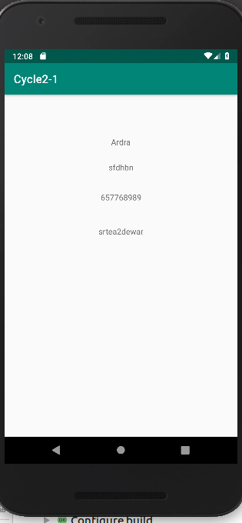
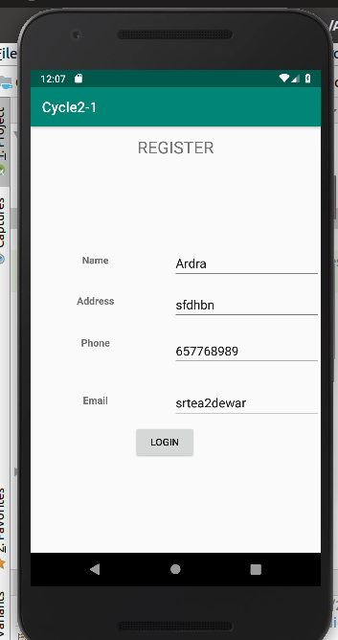

2. Design a simple Calculator using GridLayout and Cascaded LinearLayout

XML
<?xml version="1.0" encoding="utf-8"?>
<LinearLayout xmlns:android="http://schemas.android.com/apk/res/android"
xmlns:app="http://schemas.android.com/apk/res-auto"
xmlns:tools="http://schemas.android.com/tools"
android:layout_width="match_parent"
android:layout_height="match_parent"
android:orientation="vertical"
tools:context=".MainActivity">
<HorizontalScrollView
android:layout_width="match_parent"
android:layout_height="0dp"
android:layout_weight="1">
<LinearLayout
android:layout_width="match_parent"
android:layout_height="match_parent"
android:orientation="vertical">
<TextView
android:id="@+id/showValues"
android:layout_width="wrap_content"
android:layout_height="wrap_content"
android:textSize="50dp" />
<TextView
android:id="@+id/showResults"
android:layout_width="wrap_content"
android:layout_height="wrap_content"
android:textSize="100dp" />
</LinearLayout>
</HorizontalScrollView>
<GridLayout
android:layout_width="match_parent"
android:layout_height="0dp"
android:layout_weight="2"
android:columnCount="4"
android:orientation="horizontal"
android:rowCount="5"
android:useDefaultMargins="true">
<Button
android:id="@+id/delete"
android:layout_columnSpan="4"
android:text="C" />
<Button
android:id="@+id/b1"
android:text="1" />
<Button
android:id="@+id/b2"
android:text="2" />
<Button
android:id="@+id/b3"
android:text="3" />
<Button
android:id="@+id/divide"
android:text="/" />
<Button
android:id="@+id/b4"
android:text="4" />
<Button
android:id="@+id/b5"
android:text="5" />
<Button
android:id="@+id/b6"
android:text="6" />
<Button
android:id="@+id/multiply"
android:text="*" />
<Button
android:id="@+id/b7"
android:text="7" />
<Button
android:id="@+id/b8"
android:text="8" />
<Button
android:id="@+id/b9"
android:text="9" />
<Button
android:id="@+id/subtract"
android:text="-" />
<Button
android:id="@+id/bpoint"
android:text="." />
<Button
android:id="@+id/b0"
android:text="0" />
<Button
android:id="@+id/equal"
android:text="=" />
<Button
android:id="@+id/add"
android:text="+" />
</GridLayout>
</LinearLayout>
JAVA

package com.example.sjcet.cycle2_2;
import android.support.v7.app.AppCompatActivity;
import android.os.Bundle;
import android.view.View;
import android.widget.Button;
import android.widget.TextView;
public class MainActivity extends AppCompatActivity {
TextView number, values;
double num1=0, num2=0, ans = 0;
boolean add, minus, product, divide, decimal;
Button b1, b2, b3, b4, b5, b6, b7, b8, b9, b0, sum, sub, mul, div, deci, equal, clear;
@Override
protected void onCreate(Bundle savedInstanceState) {
super.onCreate(savedInstanceState);
setContentView(R.layout.activity_main);
number = findViewById(R.id.showResults);
values = findViewById(R.id.showValues);
b0 = findViewById(R.id.b0);
b1 = findViewById(R.id.b1);
b2 = findViewById(R.id.b2);
b3 = findViewById(R.id.b3);
b4 = findViewById(R.id.b4);
b5 = findViewById(R.id.b5);
b6 = findViewById(R.id.b6);
b7 = findViewById(R.id.b7);
b8 = findViewById(R.id.b8);
b9 = findViewById(R.id.b9);
sum = findViewById(R.id.add);
sub = findViewById(R.id.subtract);
mul = findViewById(R.id.multiply);
div = findViewById(R.id.divide);
deci = findViewById(R.id.bpoint);
equal = findViewById(R.id.equal);
clear = findViewById(R.id.delete);
b0.setOnClickListener(new View.OnClickListener() {
@Override
public void onClick(View view) {
number.setText(number.getText() + "0");
}
});
b1.setOnClickListener(new View.OnClickListener() {
@Override
public void onClick(View view) {
number.setText(number.getText() + "1");
}
});
b2.setOnClickListener(new View.OnClickListener() {
@Override
public void onClick(View view) {
number.setText(number.getText() + "2");
}
});
b3.setOnClickListener(new View.OnClickListener() {
@Override
public void onClick(View view) {
number.setText(number.getText() + "3");
}
});
b4.setOnClickListener(new View.OnClickListener() {
@Override
public void onClick(View view) {
number.setText(number.getText() + "4");
}
});
b5.setOnClickListener(new View.OnClickListener() {
@Override
public void onClick(View view) {
number.setText(number.getText() + "5");
}
});
b6.setOnClickListener(new View.OnClickListener() {
@Override
public void onClick(View view) {
number.setText(number.getText() + "6");
}
});
b7.setOnClickListener(new View.OnClickListener() {
@Override
public void onClick(View view) {
number.setText(number.getText() + "7");
}
});
b8.setOnClickListener(new View.OnClickListener() {
@Override
public void onClick(View view) {
number.setText(number.getText() + "8");
}
});
b9.setOnClickListener(new View.OnClickListener() {
@Override
public void onClick(View view) {
number.setText(number.getText() + "9");
}
});
deci.setOnClickListener(new View.OnClickListener() {
@Override
public void onClick(View view) {
number.setText(number.getText() + ".");
}
});
clear.setOnClickListener(new View.OnClickListener() {
@Override
public void onClick(View view) {
number.setText("");
values.setText("");
}
});
sum.setOnClickListener(new View.OnClickListener() {
@Override
public void onClick(View view) {
if (number.getText() != null) {
num1 = Float.parseFloat(number.getText() + "");
add = true;
}
values.setText(number.getText() + " +");
number.setText(null);
}
});
sub.setOnClickListener(new View.OnClickListener() {
@Override
public void onClick(View view) {
if (number.getText() != null) {
num1 = Float.parseFloat(number.getText() + "");
minus = true;
}
values.setText(number.getText() + " -");
number.setText(null);
}
});
mul.setOnClickListener(new View.OnClickListener() {
@Override
public void onClick(View view) {
if (number.getText() != null) {
num1 = Float.parseFloat(number.getText() + "");
product = true;
}
values.setText(number.getText() + " *");
number.setText(null);
}
});
div.setOnClickListener(new View.OnClickListener() {
@Override
public void onClick(View view) {
if (number.getText() != null) {
num1 = Float.parseFloat(number.getText() + "");
divide = true;
}
values.setText(number.getText() + " /");
number.setText(null);
}
});
equal.setOnClickListener(new View.OnClickListener() {
@Override
public void onClick(View view) {
if (add == true || minus == true || product == true || divide == true) {
if (number.getText() != null ) {
num2 = Float.parseFloat(number.getText() + "");
values.setText(values.getText() + " " + number.getText());
if (add == true)
ans = num1 + num2;
add = false;
if (minus == true)
ans = num1 - num2;
minus = false;
if (product == true)
ans = num1 * num2;
product = false;
if (divide == true)
ans = num1 / num2;
divide = false;
number.setText(ans + "");
num2 = ans;
num1 = 0;
}
}
}
});
}
}
OUTPUT

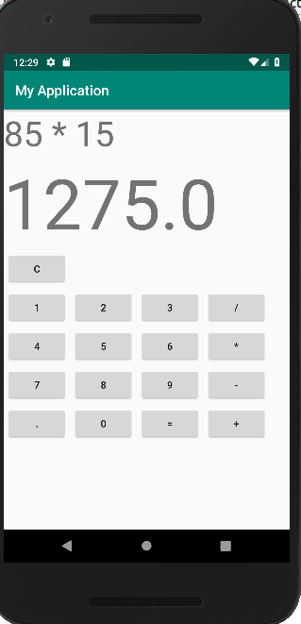

3. Create a Facebook page using RelativeLayout; set properties using .xml file

XML

<?xml version="1.0" encoding="utf-8"?>
<RelativeLayout android:layout_width="match_parent"
xmlns:android="http://schemas.android.com/apk/res/android"
android:layout_height="match_parent"
android:background="#3b5998"
android:orientation="vertical">
<ImageView
android:layout_width="300dp"
android:layout_height="80dp"
android:layout_gravity="center"
android:src="@drawable/img1"
android:id="@+id/im1"
android:layout_marginLeft="60dp"
android:layout_marginTop="60dp"
android:layout_marginRight="20dp"/>
<EditText
android:layout_width="match_parent"
android:layout_height="wrap_content"
android:layout_marginLeft="20dp"
android:layout_marginTop="80dp"
android:layout_marginRight="20dp"
android:backgroundTint="#d3d3d3"
android:hint="Username or Email"
android:inputType="textEmailAddress"
android:maxLines="1"
android:padding="10dp"
android:textColor="#ffffff"
android:textColorHint="#d3d3d3"
android:id="@+id/ed1"
android:layout_below="@+id/im1"/>
<!--EditText for user password-->
<EditText
android:layout_width="match_parent"
android:layout_height="wrap_content"
android:layout_marginLeft="20dp"
android:layout_marginTop="10dp"
android:layout_marginRight="20dp"
android:backgroundTint="#d3d3d3"
android:hint="Password"
android:inputType="textPassword"
android:maxLines="1"
android:padding="10dp"
android:textColor="#ffffff"
android:textColorHint="#d3d3d3"
android:id="@+id/ed2"
android:layout_below="@+id/ed1"/>
<!-- Login Button for Facebook Log In-->
<Button
android:id="@+id/btnLogin"
android:layout_width="match_parent"
android:layout_height="wrap_content"
android:layout_marginLeft="20dp"
android:layout_marginTop="35dp"
android:layout_marginRight="20dp"
android:backgroundTint="#5c6bc0"
android:padding="10dp"
android:text="Log In"
android:textColor="#ffffff"
android:textSize="16sp"
android:textStyle="bold"
android:layout_below="@+id/ed2"/>
</RelativeLayout>

JAVA

package com.example.sjcet.cycle2_3;
import android.support.v7.app.AppCompatActivity;
import android.os.Bundle;
public class MainActivity extends AppCompatActivity {
@Override
protected void onCreate(Bundle savedInstanceState) {
super.onCreate(savedInstanceState);
setContentView(R.layout.activity_main);
}
}

OUTPUT

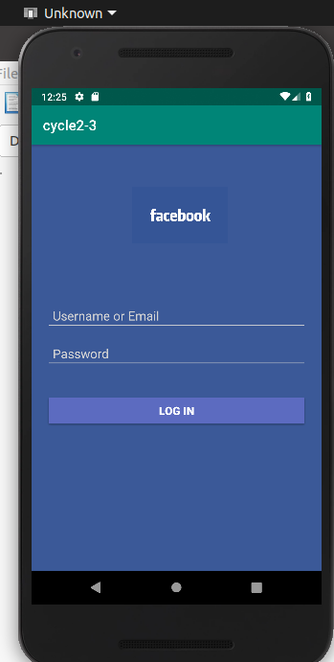

4. Develop an application that toggles image using FrameLayout

xml

<?xml version="1.0" encoding="utf-8"?>
<FrameLayout android:layout_width="match_parent"
xmlns:android="http://schemas.android.com/apk/res/android"
android:layout_height="match_parent"
android:id="@+id/framelayout">
<ImageView
android:id="@+id/imageview"
android:layout_width="match_parent"
android:layout_height="match_parent"
android:scaleType="fitCenter"
android:src="@drawable/sky" />
<Button
android:id="@+id/b1"
android:layout_width="wrap_content"
android:layout_height="wrap_content"
android:onClick="click"
android:text="toggle image"/>
</FrameLayout>
java

package com.example.sjcet.cycle2_4;
import android.support.v7.app.AppCompatActivity;
import android.os.Bundle;
import android.view.View;
import android.widget.ImageView;
public class MainActivity extends AppCompatActivity {
ImageView img;
boolean onclick=false;
@Override
protected void onCreate(Bundle savedInstanceState) {
super.onCreate(savedInstanceState);
setContentView(R.layout.activity_main);
}
public void click(View view) {
ImageView img = (ImageView) findViewById(R.id.imageview);
if(!onclick){
img.setImageResource(R.drawable.sky);
onclick=true;
}
else if(onclick){
img.setImageResource(R.drawable.flower);
onclick=false;
}
}
}
OUTPUT
